An Easy Read Companion

The CBR Gals Network

Disability Inclusion

Action Plan

Published 23 June 2023

How To Use This Companion

This guide was written by the CBR Gals Network. Accessibility is important to us and has been since we started in 2018.
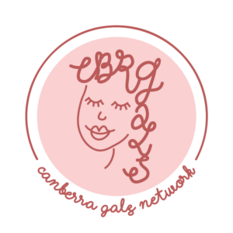

CBR Gals is a group that helps women and gender-diverse people in Canberra. We bring them together and improve all areas of their lives.

We have written this companion as a summary of our Disability Inclusion Action Plan. We will call the Disability Inclusion Action Plan the ‘DIAP’.
The DIAP will tell you the main ideas we have to make our events and online pages more accessible.

It uses some pictures that we made or found to explain ideas.

If you want, you can ask for help from a friend, family member or support person to read this plan.

If you want to read the bigger plan, we have published it on our website:
https://cbrgals.com/diap/

What Is In This Plan
How To Use This Companion Page 2
What Is In This Plan Page 4
Introduction Page 5
About Us Page 7
Why We Want This Plan Page 8
Legislation Page 9
Consultation Page 10
What We Are Going To Do Page 12
How We Will Do It Page 14
Our Team Page 19
Contact Us Page 20
Word List Page 21
Resources Page 23

Introduction
The Canberran government found that over 80,000 people are living with disability.

This circle is the Canberra population.

The red part shows 19.4% of people live with disability, which is 80,000 Canberrans.

We want to make our network more accessible and inspire other groups to do the same. If everyone creates a DIAP like this, it will make the whole Canberra community better.

We use person-first language, as recommended by the Government. We also follow other guidelines to make things easy to read.

We consulted with others and considered their advice. We will publish this plan on our website and as a document to make it easy to find and read.

About Us
CBR Gals is all about including everyone and making connections. We want everyone to feel like they belong. And we want to celebrate the different people in our community.

Our plan is to make our Network friendly and easy to access, and we worked with others to make it happen. We're proud to follow our values and empower our community to shine.

Rae Knopik
Founder and President
6 March 2023

Why We Want This Plan
At CBR Gals, we want everyone to feel welcome.

Our plan is all about making sure people living with disability can take part in everything we do.

We talked to our network to make sure we're doing the right things to help everyone join in.

We are committed to having events that are accessible to everyone, now and in the future.

We will make sure everyone feels included. This will build a more connected community for all Gals.

Legislation
CBR Gals follows laws and rules to make sure people living with disability feel included. But, this plan goes beyond that to create even more inclusive communities.

We follow laws like the Disability Discrimination Act and the Human Rights Commission Act. These are written documents by the government that protect the rights of people living with disability.

We stay updated on the laws and make changes if we need to.

We also look at a government plan called the ACT Disability Strategy. It helps people living with disability and talks about issues like isolation, discrimination, awareness, and finances.

We want to make a positive difference in these areas.

Consultation
Consulting with our community is very important for our DIAP. We want to be open and involve everyone.

We started by asking people through emails and social media. We had our first meeting with four community members in November 2022.

Our staff and volunteers who are living with disability, or have knowledge about disability inclusion helped us. We also asked for feedback in our newsletters to know what our community thinks.

We talked with board members to get their opinion during the plan's development.

We also spoke to community members to make sure the plan is right. For example, we had a talk with an expert in Disability Inclusion in May 2023, about how to present the plan.

We had a final consultation in June 2023, and afterwards the plan was emailed to CBR Gals community members to read and give their ideas.

What We Are Going To Do
We have four main things to focus on for our DIAP:

Online:

This will mean we add image descriptions to pictures and content.

We will also edit the website to make it easier to read. When we do this, we will create a menu on our website so everyone can zoom in, change the colour of text, or read-aloud.

Events:

We will give information in advance about how to access the venue. We will make sure there are ramps and lifts for every event.

We will also offer concession tickets.

In the future, we would like to hire translators and sign language interpreters.

Organisation:

We will help everyone in our team. We will make sure we have an inclusive workplace.

Education:

We will share content that will help with awareness.

We will check our progress with the help of our board, staff, and volunteers. We'll also listen to feedback from people living with disability to see where we can do better.

How We Will Do It

Make sure all places we use for events can be accessed by people with different disabilities.
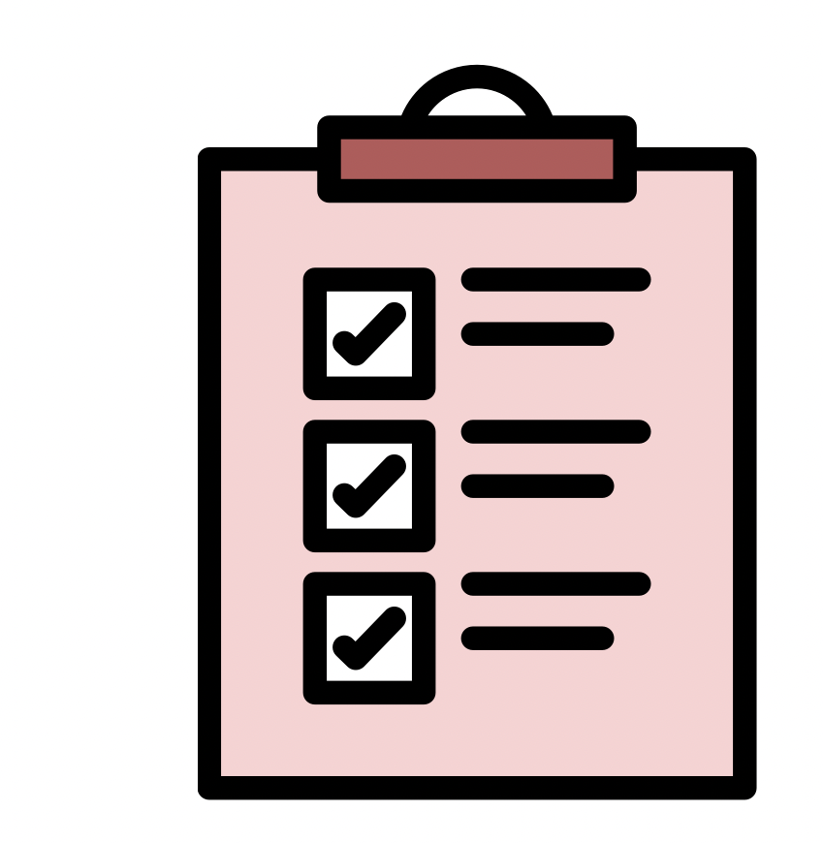

We will follow a special Event Checklist to make sure that venues meet the basic standards. The checklist will be shared with our team and event volunteers.

This will happen for every event and our Operations Officer will be in charge. To see if we are doing well, we will review our event plans and get feedback.

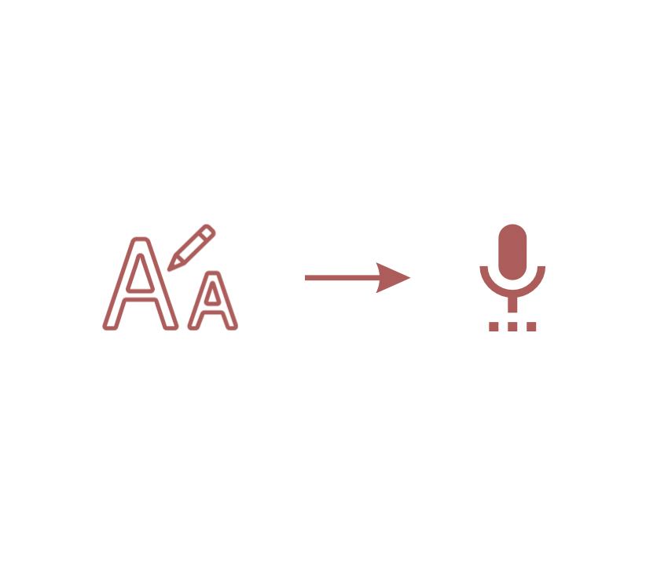
Set up a plan to raise funds and make our website easier to read.

We will raise funds to add tools to our website, like changing font size, colours, and voice reading. These tools will help more people use our website.

This will happen in the next twelve months and the Operations Officer and Non-Executive Head of Fundraising will be in charge.

We will know we are doing well when we get funds, and add the tools to our website. But we will get feedback to make sure it is working.

We will make a plan to find and make
social media posts. At the same
time, this will help our community learn more.

We will continue to post things that uplift and support women and gender-diverse people living with disability. The Operations Officer and the Non-Executive Head of Communications will be in charge.

To see if we are doing well, we will check how many people like our posts, and get feedback.

Partner with people who are living with disability to organise events.

We will work with women and gender-diverse community members. These events aim to connect and empower Gals in Canberra.

We will continue to create these events. The Operations Officer and event volunteers will be in charge. We will know how we are doing by checking the number of partnerships and diverse attendance. We will also get feedback.

Raise funds and provide training for staff
and volunteers.

This training will teach our team how to create an inclusive environment.

This will happen in the next six months. The President will be in charge. We will know we are doing well when we have created these training materials. We will also get feedback.

Support people living with disability to make sure they can participate in all our events
and activities.

This will continue to happen. The Board and Operations Officer will be in charge.

We will get feedback to see if our support is helping.

Review the plan every year to find areas we
can improve.

The Board Secretary will be in charge of looking at the plan every year to see if we can make it better. We will see if we achieved our goals, and get feedback.

Our Team

At CBR Gals, we believe in including everyone and valuing their ideas. We want to make sure people living with disability are part of our decisions.

To do this, we will:
- Have an experienced group of people check our progress to make sure our plans are working.
- Make sure jobs and volunteer roles can be done by people living with disability. Ask people that want to join if they need any help and encourage them to apply.
- Teach our staff, board members, and volunteers how to include people living with disability.
- Listen to our community, especially people living with disability, to make sure we are doing things right.

We know that being inclusive is an ongoing journey. We will keep learning and improving to treat everyone fairly and with respect.

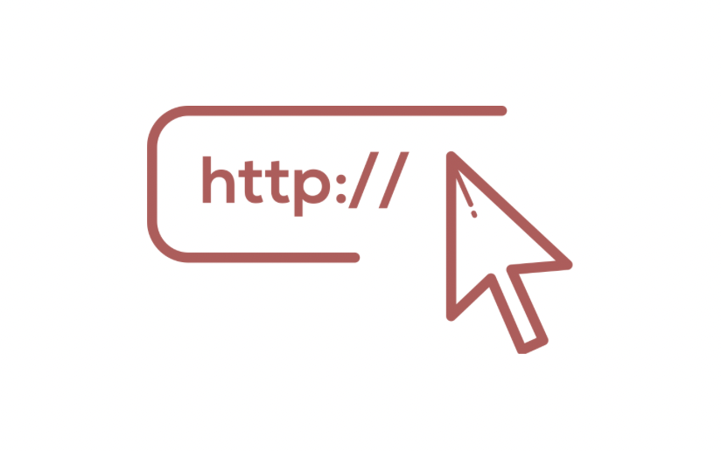
Contact Us

We have made an event checklist to make sure that every event is accessible. This is in our bigger DIAP. You can see it at:
https://cbrgals.com/diap/

More information about the accessibility of each event will be on our website. We also have an option to add your accessibility requirements when you checkout.

If you would like more information, want to read this plan differently, or have ideas of how we can be better, reach out to us at: enquiries@cbrgals.com

Word List
This list will explain the meaning of all the bold words used in this DIAP. We have included the places we found these definitions in the resources list on the next page.

Accessible / Accessibility
Accessibility means to make sure that people living with disability can get the same information, opportunities, and services easily.

Concession
Concession means a special discount that is lower than the normal ticket price. It means more people can join our events.

Consultation
Consultation means the meetings we had to talk about the DIAP.

Gals
Gals means all the women and gender-diverse people in the CBR Gals community.

Gender-diverse
Gender-diverse means people that identify their gender differently. They may not want to be ‘male’ or ‘female’, because these traditional names can be limiting.

Inclusion / Inclusive
Making sure everyone feels welcome and safe in a place or group.

Person-first Language
Person-first language is what the Government says is better. It means we will always say “person living with disability” rather than “disabled person”. This is to be more respectful.

Resources

Resources means the websites and other information that we researched to write this DIAP.

Resources
This is a list of documents we read while we wrote this plan. And any pictures we used in this document.

Definitions
A Gender Agenda. “What is Gender Diversity?” Date Unknown. https://genderrights.org.au/information-hub/what-is-gender-diversity/

Case Western Reserve University. "What is Accessibility?" Date Unknown. https://case.edu/accessibility/what-accessibility#:~:text=Accessible%20means%20a%20person%20with,substantially%20equivalent%20ease%20of%20use

Collins English Dictionary. “Definition of 'concession'.” Date Unknown. https://www.collinsdictionary.com/dictionary/english/concession#:~:text=A%20concession%20is%20a%20special%20price%20which%20is%20lower%20than,%5BBritish%5D

Collins English Dictionary. “Definition of 'consultation'.” Date Unknown. https://www.collinsdictionary.com/dictionary/english/consultation#:~:text=A%20consultation%20is%20a%20meeting,Consultation%20is%20discussion%20about%20something

Inclusive Employers. “What is inclusion?” Date Unknown. https://www.inclusiveemployers.co.uk/about/what-is-workplace-inclusion/#:~:text=Cambridge%20Dictionary%27s%20official%20definition%20for,and%20respected%20as%20an%20individual.

Image Credit
Images in this document have either been created by our team, or sourced from stock imagery sites. Whilst attribution is not required, the following is a reference list of photos that have been included in this companion to our DIAP.

Andrea Piacquadio. Woman Draw a Light bulb in White Board. February 18, 2020. Pexels. https://www.pexels.com/photo/woman-draw-a-light-bulb-in-white-board-3758105/

Anna Shvets. People on a Video Call. April 24, 2020. Pexels. https://www.pexels.com/photo/people-on-a-video-call-4226122/

Marcus Aurelius. Women Having Meeting at the Coffee Shop. March 6, 2020. Pexels. https://www.pexels.com/photo/women-having-meeting-at-the-coffee-shop-4063797/

RF._.studio. Women at the Meeting. February 26, 2020. Pexels. https://www.pexels.com/photo/women-at-the-meeting-3810795/

Websites
ACT Government. “ACT Disability Strategy.” Consultation Snapshot. Document published December 2022, webpage last modified May 19, 2023. https://www.communityservices.act.gov.au/disability_act/act-disability-strategy

ACT Government. “ACT Disability Strategy.” YourSay Conversations. Date unknown. https://yoursayconversations.act.gov.au/act-disability-strategy

Australian Government. “Australia’s Disability Strategy 2021–2031: An Easy Read guide.” Disability Gateway. Published 2021. https://www.disabilitygateway.gov.au/sites/default/files/documents/2021-12/1906-easy-read-summary-strategy.pdf

Australian Government. “Easy Read.” Style Manual. Last modified September 6, 2021. https://www.stylemanual.gov.au/content-types/easy-read

Australian Government. “People with disability.” Style Manual. Last modified August 22, 2022. https://www.stylemanual.gov.au/accessible-and-inclusive-content/inclusive-language/people-disability

Australian Human Rights Commission (AHRC). “Access for all: Improving accessibility for consumers with disability”. Employers. Last Revised June, 2016. https://humanrights.gov.au/our-work/employers/access-all-improving-accessibility-consumers-disability

Australian Human Rights Commission (AHRC). “Action plans and action plan guides”. Disability Rights. Date unknown. https://humanrights.gov.au/our-work/disability-rights/action-plans-and-action-plan-guides

Australian Human Rights Commission (AHRC). “Convention on the Rights of Persons with Disabilities - Human rights at your fingertips”. Commission – General. Date Unknown. https://humanrights.gov.au/our-work/commission-general/convention-rights-persons-disabilities-human-rights-your-fingertips#

Australian Human Rights Commission (AHRC). “World Wide Web Access: Disability Discrimination Act Advisory Notes ver 4.1 (2014)”. Disability Rights. Published 2014. https://humanrights.gov.au/our-work/disability-rights/world-wide-web-access-disability-discrimination-act-advisory-notes-ver?_ga=2.163502076.197045254.1680063706-1419799818.1680063706

Australian Network on Disability. “Check your progress with the Index.” Date unknown. https://and.org.au/how-we-can-help-you/check-your-progress/

Australian Network on Disability. “Provide an accessible and inclusive workplace.” Date unknown. https://and.org.au/how-we-can-help-you/provide-an-accessible-and-inclusive-workplace/

Department of Foreign Affairs and Trade (DFAT). “Creating documents that meet accessibility guidelines.” Date Unknown. https://www.dfat.gov.au/about-us/about-this-website/accessible-documents/creating-documents-meet-accessibility-guidelines

Involved CBR. “Disability Action and Inclusion Plans (DAIPs)”. Date Unknown. https://www.involvedcbr.com.au/our-foundations/where-were-going/disability-action-plan

People With Disability Australia. “What Do I Say? A Guide to Language About Disability.” Published 2019. https://pwd.org.au/wp-content/uploads/2019/08/PWDA_LanguageGuide_A5_WEB.pdf

Vision Australia. "Online and print inclusive design and legibility considerations." Date unknown. https://www.visionaustralia.org/resources/digital-access/resources/tip-sheets-whitepapers/web-content-accessibility-guidelines

Vision Australia. "Typography in Inclusive Design Part 2: Choosing Typefaces and Laying Out Text Content." Published March 23, 2022. https://www.visionaustralia.org/business-consulting/digital-access/blog/typography-in-inclusive-design-part-2

Vision Australia. "Web content accessibility guidelines." Date unknown. https://www.visionaustralia.org/resources/digital-access/resources/tip-sheets-whitepapers/web-content-accessibility-guidelines

Legislative Materials
Australian Human Rights Commission Act 1986 (Cth). Compilation no. 53. December 13, 2022. https://www.legislation.gov.au/Details/C2022C00369

Convention on the Rights of Persons with Disabilities, GA Res 61/106, AN Doc A/RES/61/106 (24 January 2007, adopted 13 December 2006) Article 3.

Discrimination Act 1991 (ACT). vR49. August 28, 2020. https://www.legislation.act.gov.au/a/1991-81

Disability Discrimination Act 1992 (Cth). Compilation No. 36. December 13, 2022. https://www.legislation.gov.au/Details/C2022C00367

Disability Services Act (National Standards for Disability Services) Determination 2014 (Cth). Compilation No. 1. April 1, 2021. https://www.legislation.gov.au/Details/F2021C00327

Human Rights Act 2004 (ACT). vR14. April 6, 2022. https://www.legislation.act.gov.au/a/2004-5

Human Rights Commission Act 2005 (ACT). vR40. December 17, 2022. https://www.legislation.act.gov.au/a/2005-40

